MY DATA RIGHTS

GDPR COMPLAINTS GUIDE
for Industrial and Reformatory School Survivors

Written by Cassie Roddy-Mullineaux with input from Mary Harney, Pedro Cantero, and Renk Senem Gurgen, LLM candidates at the Irish Centre for Human Rights, National University of Ireland, Galway.

Many thanks also to Dr Maeve O´Rourke, Irish Centre for Human Rights, NUI Galway; Dr Sarah-Anne Buckley, Discipline of History, NUI Galway; Claire McGettrick; Adoption Rights Alliance; and Justice for Magdalenes Research. Special thanks to Emer Lyons at Dillon Leetch and Comerford, Solicitors, Galway for her pro bono assistance and to Aisling Legros for the cover page sketch of the Good Shepherd Industrial School, Cork.

Cite as Cassie Roddy-Mullineaux and others, GDPR Complaints Guide for Industrial and Reformatory School Survivors (mydatarights.ie, April 2020).

This guidebook is not legal advice.

Is this EU General Data Protection Regulation (GDPR) Complaints Guide for you?

Were you detained in an Irish Industrial School or a Reformatory school between the years 1940-1996?
Have you already used the GDPR to try to obtain your personal data (e.g. copies of your medical records, educational records or any personal records held by various government agencies) from the relevant organisations (known as 'data controllers' or just 'controllers'), such as the Department of Education and Skills or the Health Service Executive, who are holding your personal data?
If not, please see our GDPR Access Guide (available on the mydatarights.ie website) which will guide you through the GDPR process and help you to make a data subject access request.
Otherwise, we hope that you have received the personal data you requested from these organisations.
But, if you are unhappy with the response to your request, this Guide will help you to make a complaint to the Irish Data Protection Commission ("DPC") using the online complaint form available on the DPC's website.
Remember:
- If the data controller did not respond within 30 days, you have a right to complain!
- If the data controller has heavily redacted your records, or if it has omitted any of your personal data from their response, you should also complain!

Before you begin: FAQs

Is there anything I should do before I make a complaint to the DPC?

If you haven't received a response to your request within one month of your initial request or at all, and you haven't already sent a reminder letter/email to the data controller organisation about your request, then we recommend that you send one as soon as possible, referencing your original request and the date on which you sent it.
Similarly, if you received a response but you are concerned the organisation has not provided all of the data you requested, you should contact them in writing (letter/email), setting out the personal data you know or believe to exist and which has not been provided to you, and requesting that they provide it to you.
If you are not satisfied with the organisation's response for another reason (for instance, if you believe an 'exemption' – as explained in Section 3.4.1.3 – has been incorrectly applied in refusing you access to your data), you should also contact them in writing to let them know why you are dissatisfied, and asking for these issues to be addressed.
Please refer to Section 3.4 - Your Complaint for more information on what to include in your letter/email.
The reason we advise that you write to the organisation before making your complaint to the DPC (essentially giving the organisation one last chance to comply with your request) is because it may help your concern to be addressed sooner. The DPC's complaint form also asks if you have taken this step. However, you are still entitled make a complaint without writing to the organisation.

I have now decided to complain to the DPC – what happens next?

Complaints to the DPC are usually made online. The form on the DPC's website is very easy to fill out, and you will find instructions on how to fill it out further on in this Guide. If you are not used to using a computer or do not have access to one, you could consider asking a friend or relative to help you to fill out the online form. You might also consider going to your local Family Resource Centre for assistance. If you ask someone for help in making your complaint, make sure to show them this Guide.
If you would prefer to make a complaint using a paper form, or if you have a disability and need special assistance in making your complaint, you should contact the DPC's Access Officer, Mr Alan O'Grady. The DPC's Access Officer is obliged to provide assistance to persons with disabilities under Section 26(2) of the Disability Act 2005.
Here are the contact details for the DPC's Access Officer:
Access Officer contact details:
Alan O'Grady
Access Officer
Data Protection Commission
21 Fitzwilliam Square
Dublin 2
D02 RD28
Ireland
+353 57 868 4800 – Help desk number
Email: dpcaccessofficer@dataprotection.ie.

Will the DPC share my complaint form with others?
When you raise a complaint with the DPC about a particular organisation, the DPC will contact the organisation and share the details of your complaint with it in order to confirm whether the organisation has your data, and so that the organisation can respond.
The DPC will usually do this by sharing a copy of your completed online webform directly with the organisation. Sometimes the DPC will decide not to share all of the information provided in your webform with the organisation, for instance if it is personal data of another person, or where you have specifically asked for information not to be shared because it is sensitive or confidential. However, because sharing this information at the DPC's discretion, we do not recommend that you include anything in your form that you do not wish to be shared.

Step By Step Guide to completing the Complaint Form
The DPC's complaint form is available on the DPC's website, here. This section of the Guide aims to guide you through the step by step process of filling out the complaint form.
It includes screen shots from the DPC's website so you can see what the form looks like before you begin completing it.
Unfortunately, you cannot exit the form and return to it later, so please allow yourself enough time to complete it in one go. However, your information should save if you need to navigate forwards and backwards between different pages of the form.
Please make sure that you have a good internet connection. Having a friend or family member nearby will help if you run into any technical difficulties.
Please also make sure you have soft-copies of relevant documents (see Section 3.5 - Documentation) saved to your computer before you begin because you will need to upload these at the very end of the form.
Please review this Guide in its entirety before you begin filling out the form so you know what information you will need to upload with it.

Form: Preliminary Questions
First, you will be asked to answer some preliminary questions:

The first thing you will be asked is if you are contacting the DPC as an individual (or on behalf of an individual(s)), or on behalf of an organisation(s), or in relation to an existing case).

You should tick the option 'as an individual'.
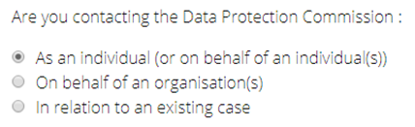

You will then be asked to confirm that your complaint concerns personal data – say yes.
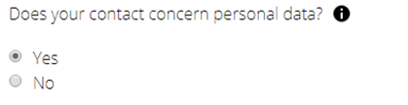

You will also be asked if the complaint is about your own personal data – see below. Please answer yes.
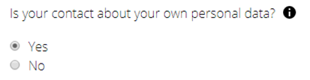

You will then be asked to select the reason why you are contacting the DPC. You should select the option 'I have a concern relating to a request to access my personal data'.
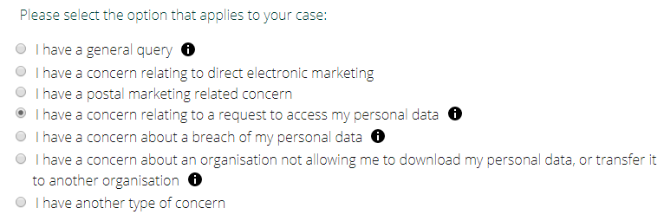

Form: Personal details

Once you select 'continue' you will be prompted to fill out your personal details. You will need to provide your full name and email address (this is compulsory). You can also provide additional contact details including a phone number and postal address. Additionally, you must provide the name of the organisation to which your concern relates (e.g. the Department of Education and Skills). If you have the name / email / role of any contact within the organisation or any reference number which the organisation has provided you with, you can include this too – see below.
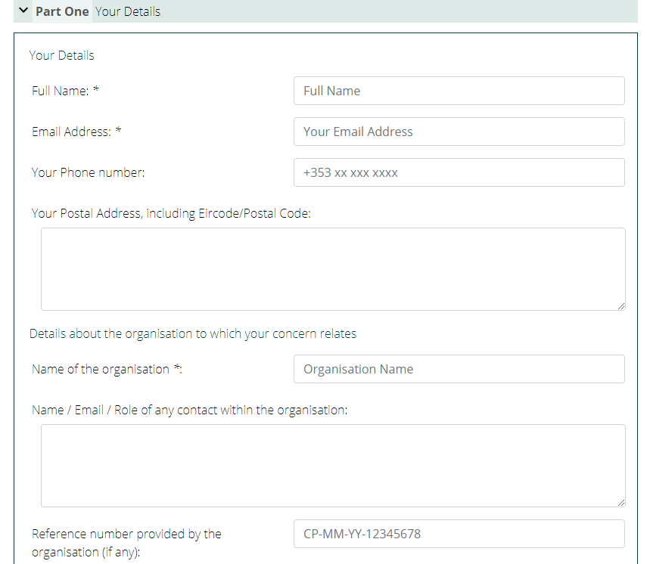

If you have not complained to the DPC about this specific matter before then please select 'No' – see below.
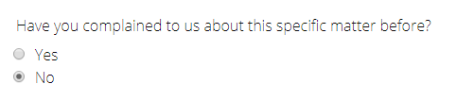

Form: Details of your access request

You will then be asked to confirm that you have already made an access request – please say yes.
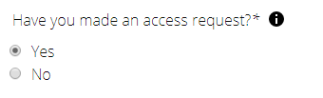

You will also need to confirm that this request was made over one month ago (as the controller generally has one month, from the date it receives your access request, to respond to your request).

You will be asked to enter the date of your access request – see below.
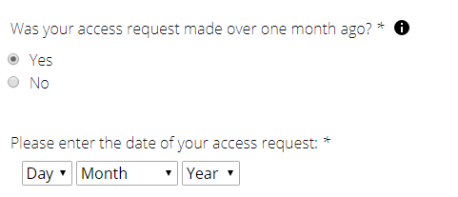

Form: Your Complaint

You must then outline the reason for your complaint – there are four options to choose from:
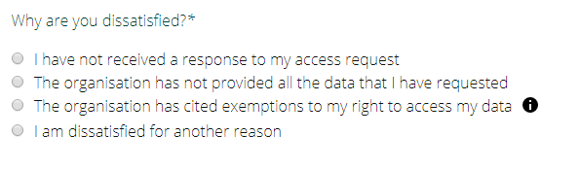

Option 1 - No response to an access request

If you have not received a response to your access request you should select this option. You will be asked if you have sent a reminder letter (which can also be an email) to the organisation. If you have sent one, you should provide the date on which you sent it. You can still submit your complaint even if you haven't sent a reminder letter; however, it is recommended that you send one (please see Section 2 of this Guide).
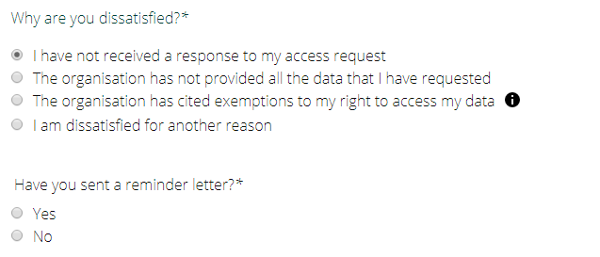

Option 2 - Incomplete response to an access request

If you feel the organisation has not provided all of the data you have requested, then you should select this option. You will be asked if you have raised this issue in writing with the organisation. You can still submit your complaint to the DPC even if you haven't done this; however, we recommend that you send a letter/email to the organisation (see Section 2 of this Guide).
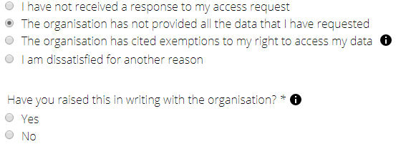

Option 3 - Exemptions being used to withhold data that may be applied incorrectly

An exemption is a legally valid basis on which a data controller can refuse you access to your personal data. However, exemptions should be used sparingly and they must comply with certain rules. Data controllers can sometimes use exemptions incorrectly (Section 3.4.3.1.1 provides more information on this).
If the organisation has cited exemptions to your right to access your data, you should select this option. You will be asked if you have raised this issue in writing with the organisation. You can still submit your complaint to the DPC even if you haven't done this; however, we recommend that you send a letter/email (see Section 2 of this Guide) to the organisation, using the arguments that we provide in Section 3.4.3.1.1 – How can I argue that an exemption has been incorrectly applied?
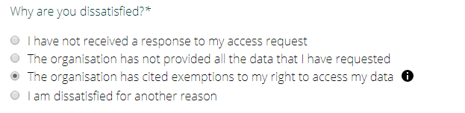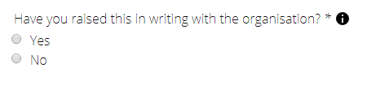

Option 4 – Other reason for dissatisfaction

If your complaint does not relate to the other three options, then please select this option. You will be asked if you have raised this issue in writing with the organisation. You can still submit your complaint to the DPC even if you haven't done this, but we recommend that you send a letter/email to the organisation (see Section 2).
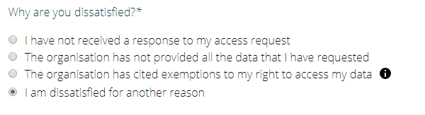

Whichever option you choose, you will be asked to outline the details of your access request in the box provided (pictured below). This should include your relationship with the organisation, the context in which the data was created, and any other relevant information about the specific data sought:

It would be useful to include the following information:
- The details of the industrial school(s) you attended; the school reference number; the approximate years of entry and discharge
- You may also wish to reference the name of your mother and father, your address before placement, and the names of any brothers and sisters who may or may have not been in an Industrial school.
- You can also supply any additional information here, which you feel may prove useful in locating your records, e.g. date of birth, any other name by which you were known in the school, a copy of documentation you may have received from the school management, details of placement after being discharged from the school, etc.
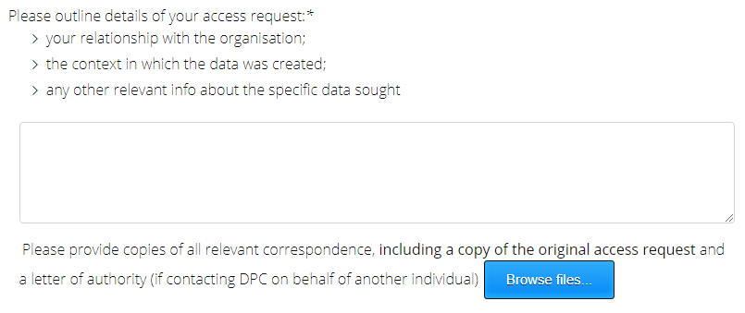

The Option that you choose will inform which other relevant information you need to include:
- For Option 1, the information you have already provided (i.e. the information set out at Section 3.4.2 – details of your access request) should be enough.
- For Option 2, you will also need to provide as much detail as you can in the box provided regarding the personal data which you think is missing;
- For Option 3, you will also need to provide details of the exemption which is being relied on by the controller, and provide your views as to why it is not validly applied (Section 3.4.3.1.1 – How can I argue that an exemption has been incorrectly applied? will help you with this).
- For Option 4, you will also need to provide as much information as you can about the reason for your dissatisfaction.

The Option that you choose will also inform which documentation and relevant correspondence you will need to upload (see Section 3.5 - Documentation). You should always upload a copy of your original access request.

How can I argue that an exemption has been incorrectly applied?

To recap, personal data includes all information identifying you or relating to you - this includes information about your physical identity, such as your physical condition and circumstances during your detention in the industrial school, your place of birth, your education records, your medical care records, the names of the people responsible for your care, your original name, and the circumstances surrounding your detention in an industrial school. Records of inspections, or other management records, may also contain your personal data if they refer to your treatment or anything else about you. Your personal data may be contained in documents other than your 'file'. Documents created for and by abuse inquiries may also contain your personal data. For example, your transcript of evidence contains your personal data. Your personal data is contained in documents you submitted to any inquiry, and in any documents that another person or an inquiry created about you.
The right of access to personal data is enshrined as part of the fundamental rights set out in Article 8 of the EU Charter of Fundamental Rights. In fact, it is the only one of the practical rights relating to personal data that is listed there. In the GDPR, this right is contained in various sections of Article 15. It is a very strong right which can only be limited in a small number of circumstances.
An exemption is a legally valid basis on which a data controller can refuse you access to your personal data. However, exemptions should be used sparingly and they must comply with certain rules. Data controllers can sometimes use exemptions incorrectly.
The exemption which is being most commonly cited by data controllers to limit your access to your data is that providing you with your personal data would 'adversely affect the rights and freedoms of others'.
The Irish Data Protection Commissioner has issued guidance which says that where a controller has concerns that complying with an access request could impact the rights and freedoms of others, instead of a blanket refusal, they should "endeavour to comply with the request insofar as possible ensuring adequate protection" for third party's rights. If a controller considers it is justified to withhold certain information, it must identify the relevant exemption, provide an explanation as to why it applies and demonstrate that reliance on the exemption is necessary and proportionate.
However, in our experience, it is likely the data controller will not give you detailed reasons (or indeed any reasons at all) as to why they are using the exemption. In other words, they will just say that releasing the data to you would 'adversely affect the rights and freedoms of others', but will not provide any further details.
This is because controllers, including government agencies, are implementing an extremely conservative interpretation of the meaning of 'personal data' and 'third party data'. In practice, this means that many records which are being released to survivors are heavily redacted. In particular, information relating to third parties (individuals other than you) may be redacted or missing, for instance information related to other persons connected with the industrial or reformatory school.
It is very important that you refer to the exemption used by the controller in your response, and say that you believe the exemption is incorrectly applied. Do not merely say that you complain and ask them to review their response because this is unlikely to be effective.
Below is some information we hope will be of use to you in writing your response (in Section 3.4.3.1.1.1 – Sample Response, we offer some suggestions for how you might include this information in a response):
- If the controller has not provided reasons why they are applying the exemption, you should ask for these reasons to be provided to you. This is line with the principle of transparency under Article 12 GDPR;

- Some information can be the personal data of two or more people at the same time. For instance, information about how a particular third party (such as a nun or priest, or other person in authority) treated you could be understood as 'mixed' personal data belonging to you and them. If the controller is refusing to provide you with data that relates to you on the basis that it is 'third party data' (or you suspect that this is the reason), you can refer them to the judgment of the Court of Justice of the European Union (CJEU) in Nowak v Data Protection Commissioner of Ireland (Case C-434/16, 20 December 2017). In this case, the CJEU stated that information may be linked to more than one individual and this does not affect the right of access: 'The same information may relate to a number of individuals and may constitute for each of them, provided that those persons are identified or identifiable, personal data' (para 45 of the Nowak judgment). Note that if the other person(s) is deceased, they do not have rights under the GDPR as the GDPR applies only to living individuals.

- Under the GDPR, personal data is data that relates to or can identify a living person either by itself or together with other available information. In most cases, data related to deceased persons is not personal data for GDPR purposes. However, if this data also identifies you or relates to you (a living person) then it should be considered personal data. (For example, a family tree would clearly be your personal data, despite containing information relating to deceased persons, because it also identifies and relates to you.) As such, any information the controller has relating to your parents, including any conversations it had with your parent about you or any other identifying information, is your personal data, even you are not specifically named or referenced in the information, because it is information identifying and relating to you.

If the controller is refusing to provide data relating to your deceased relatives because they say this is not 'personal data' (or you suspect that this is the reason), you can argue this information meets the definition of personal data under GDPR because it is information relating to you, and/or identifying you, as well as information forming part of your personal identity.

- Under the GDPR, you have a fundamental right of access to your personal data. Any balancing of your data access rights against the 'rights and freedoms of others' whose data might be compromised by you accessing your data, must meet the very high threshold set by the Irish Data Protection Commissioner in its guidance. A controller must show that its reliance on an exemption to limit your access rights is strictly necessary and proportionate. In your response, you can refer them to this high threshold for any limitation of your fundamental rights, including your right of access. It is not enough for a controller to merely state that a 'balancing test' has been completed by it. They need to show why limiting access in your specific case is both necessary and proportionate:

  - Necessary means that the controller's reliance on the exemption must be justified on the basis of objective evidence. You should ask what' objective evidence' the controller has relied upon in applying the exemption, and ask for details of this objective evidence to be provided to you (again, this is in line with the principle of transparency under GDPR).

  - Necessary also means that the 'essence' of your right of access must be respected (this will be particularly relevant if your records have been heavily redacted). If this has happened, you can refer them to the fact that such over-redaction interferes with the 'essence' of your right of access. You may want to say that the redaction renders your records effectively redundant, precluding you from exercising your right of access, and essentially emptying your right of access of its basic content.

  - Proportionality requires that you are not overly disadvantaged due to your right of access being limited, compared to the disadvantage that would occur for others if you were to receive access to your personal data. You should ask exactly how the controller has established that your right to your personal data and to knowing the most intimate basic details of your life (including in circumstances where abuse has occurred) is outweighed by the interests of another person (for example, a person who was an employee or doing a job that was in the ordinary course of their duties)? As someone who is a former industrial school and reformatory school detainee, the balancing test should be weighted in your favour – and you can emphasise this point in your response, asking them to demonstrate how their decision is necessary and proportionate in light of the harm that you have already suffered, and are continuing to suffer by being denied access to data that relates to you.

Linked to this point, is the fact that any balancing of your rights can only be with respect to the rights of other data subjects. GDPR only applies to personal data about living individuals: it does not govern data about companies or other legal bodies such as government departments, educational bodies, or religious institutions. The redaction of data relating to these bodies is also invalid for this reason. Similarly, the GDPR does not apply to data related to deceased persons (except where this information also amounts to personal data of a living individual). For this reason, any balancing of your rights cannot factor in harm to persons who are already deceased. If you suspect the redaction of data relating to a person(s) who is deceased, you can emphasise that the GDPR does not apply to data of deceased persons, and that this information should not be redacted.

Sample Response if the data controller has relied on 'rights and freedoms of others' exemption

Here are some suggestions for how you might include the information above in your complaint.
In providing your views on why the exemption has been misapplied, you should include, add to or delete wording in the [square brackets] as needed.
These are suggestions only – and, whenever you are referring to personal data, the more detail you can include on it the better (we have indicated where you should definitely provide details).
Please don't forget to include the relevant information outlined at Section 3.4.2 and Section 3.4.3 in your response, and to upload any relevant documentation (see Section 3.5 - Documentation) with your response. Please also don't forget to keep a copy of the complaint as you will have further rights of review if still not happy with the result.

[The [insert name of data controller] has said they cannot release my personal data – provide details of personal data - to me]
And / Or
[The [controller] has [also] returned my [records / some of my records - provide details of records/personal data] to me in redacted / heavily redacted form]
And
[The [controller] has cited the following exemption in [refusing to release / partially releasing my personal data]: that my right to accessing my personal data interferes with the rights and freedoms of others]
And / Or
[No explanation has been provided to me by the [controller] as to why this exemption applies in the case of my personal data. I am requesting that a full explanation be provided to me in line with the principle of transparency under GDPR.]
And / Or
[I believe that this exemption has been misapplied by the [controller] for the following reasons:]
[The [controller] has said that they cannot release [some of] my personal data because it is 'third party data', i.e. data which relates to individuals other than me – provide details.
However, the Court of Justice of the European Union (CJEU) acknowledged in Nowak v Data Protection Commissioner of Ireland (Case C-434/16, 20 December 2017) that information may be linked to more than one individual and this does not affect the right of access. The Court stated: 'The same information may relate to a number of individuals and may constitute for each of them, provided that those persons are identified or identifiable, personal data' (para 45 of the Nowak judgment)].
And / Or
[The [controller] is refusing to provide data relating to my deceased relative[s] – provide details, e.g. parent - who is a former resident of [insert name of industrial school] – provide details - as the [controller] says this is not personal data for GDPR purposes. However, this information meets the definition of personal data under GDPR since it is information which relates to me and which identifies me, and is also part of my family history. As such, I am entitled to request access to this information under GDPR and I request that this information be provided to me.]
And / Or

[The guidance issued by the Irish Data Protection Commissioner establishes a very high threshold for the balancing of my data access rights against the 'rights and freedom of others', including that any limitation to my right of access to my personal data is both necessary and proportionate.]

[The [controller] has said they have engaged in a 'balancing test' in deciding to limit my fundamental right of access under GDPR].

[It is not enough for a controller to say they have engaged in a balancing test. It must demonstrate that its reliance on the exemption and the subsequent limitation of my right of access is necessary and proportionate - and appropriate in my case].

[I ask the [controller] to provide me with the objective evidence which they relied on in deciding to limit my fundamental right of access to my personal data. This is in line with the principle of transparency under GDPR].

[As a former industrial school and reformatory school detainee, I have already suffered harm, and continue to suffer harm through the denial of my right to access my personal data. This harm means that the balance in the balancing test must be weighted in my favour, and the [controller] must demonstrate, on the basis of objective evidence, that any harm to others is foreseeable and not hypothetical, and that the harm would actually occur.]

[I ask the [controller] to inform me how it has established that my right to my personal data, including to knowing the most intimate details of my personal life [including in circumstances where abuse has occurred] is outweighed by the interests of a person who was [an employee / doing a job that was in the ordinary course of his/her duties] [and in circumstances where I have not made any legal allegation of abuse against this person].

And/Or

[I remind the data controller that any harm caused to [deceased individuals [and/or institutions] – provide details] cannot be a factor in its deciding to place limitations upon my right of access as these [persons/entities] are not data subjects under GDPR] [and redaction of information relating to these [persons/entities] is not permitted under GDPR].

And/ Or

[My personal data has been redacted / heavily redacted by the [controller] – provide details. This has rendered the information provided to me effectively worthless and has emptied my right of access of its basic content. This is an interference with the 'essence' of my right of access under GDPR.]

Documentation

Whichever option is relevant to your situation, you will be asked to provide copies of all relevant correspondence, including a copy of the original access request you made. You will need to upload these files in soft-copy as part of the webform. You may have received records in electronic form already. However, if you only have hard copies of your documentation, you can use your phone to take a photograph and upload the photograph to your computer. If you don't know how to do this, you could consider asking a friend or relative for help. Alternatively, you could contact the DPC Access Officer to ask them whether you can send your accompanying documentation by post.
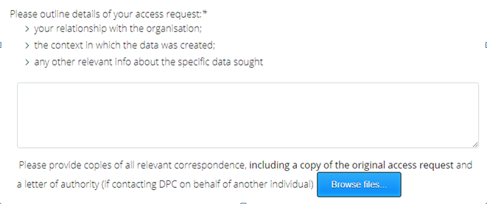

Below are suggestions for which documents should be uploaded depending on the complaint type:
No response | Incomplete Response | Exemptions applied incorrectly
- A copy of the access request.  - Any reminder letter/email sent to the data controller.  - Any other relevant correspondence on the matter, for example, if the data controller has sought proof of your identity, evidence that you have provided this. | - A copy of the access request.  - A copy of the reply received  - A copy of any letter/email sent to the data controller outlining the specific personal data that has not been provided.  - Any evidence you have of the existence of the personal data concerned.  - Any other relevant correspondence on the matter. | - A copy of the access request.  - A copy of the reply received  - A copy of any letter/email sent to data controller seeking an explanation for the use of the exemptions together with any reply received from the data controller.  - Your views in writing as to why the exemptions being relied on by the data controller are not validly applied.  - Any other relevant correspondence.

How long will it take to hear back from the DPC?
Unfortunately, we do not yet have a clear indication of how long this might take. For this reason, we always recommend that you write to the organisation first (as explained in Section 2), as this could result in your complaint being answered sooner.

Can the DPC award me compensation?
Please be aware that the DPC does not have the power to award compensation. If you wish to bring legal proceedings about a data protection issue, you should seek independent legal advice (see also section 6 below).

Next Steps
What if the DPC doesn't handle my complaint or does not inform me within three months on the progress or outcome of my complaint?
You have a right to an effective judicial remedy where the DPC does not handle your complaint or does not inform you within three months on the progress or outcome of your complaint. You can authorise a not-for-profit body, organisation or association to act on your behalf.
FLAC (Free Legal Advice Clinic) or PILA (Public Interest Law Alliance) will be a useful first port of call if you are considering this option.

We hope you succeed on your journey to access your data – and we wish you the very best of luck!
We aim to update this Guide periodically. Please let us know if you have any feedback on what you did/did not find useful, or any way in which your experience differed from what we've outlined in the Guide.

This information is the copyright of the DPC and is reproduced with permission of the DPC.
Please note that if the information you are seeking relates to a deceased relative, e.g. a parent, who was a former resident of an industrial school, this is still your personal data because it relates to your family history.
If you have complained before, then you should enter the reference number of your original complaint, and let the DPC know what the outcome of your original complaint was.
Under Article 4 (1) Of the GDPR: Personal data means any information relating to an identified or identifiable natural person (‘data subject’). An individual is ‘identified’ or ‘identifiable’ if you can distinguish them from other individuals. A name is perhaps the most common means of identifying someone. However whether any potential identifier actually identifies an individual depends on the context. A combination of identifiers may be needed to identify an individual. The GDPR provides a non-exhaustive list of identifiers, including: name; identification number; location data; and an online identifier (e.g. IP addresses and cookie identifiers which may be personal data). Other factors can identify an individual, including factors specific to the physical, physiological, genetic, mental, economic, cultural or social identity of that natural person.
Please note that other exemptions, aside from the protection of ‘rights and freedoms of others’, are outside the scope of this Guide as, in our experience, they are not being used by data controllers to refuse access to data. However, if you have experienced differently, please let us know as we aim to update this Guide periodically.
The strength of this argument may depend on the type of information involved.
There is also an argument that your family history should be understood as data relating to you under GDPR because it is so closely linked to your identity and your personal development; such connections have already been explored in the context of the right to respect for private and family life under Article 8 of the European Convention on Human Rights, and, by analogy, suggest your family history should be understood as relating to you and forming part of your identity for GDPR purposes, thereby satisfying the definition of personal data.
You will need to amend as appropriate.
Note that there is also the potential for private civil litigation in the form of a ‘data protection action’, including for compensation, against controllers who are infringing your data protection rights. The DPC does not have a role in this process.

